DIE# 15028 – ATI (EXTRUDER SIDE)
Pack on Green Buggy – Wrap arms in cardboard
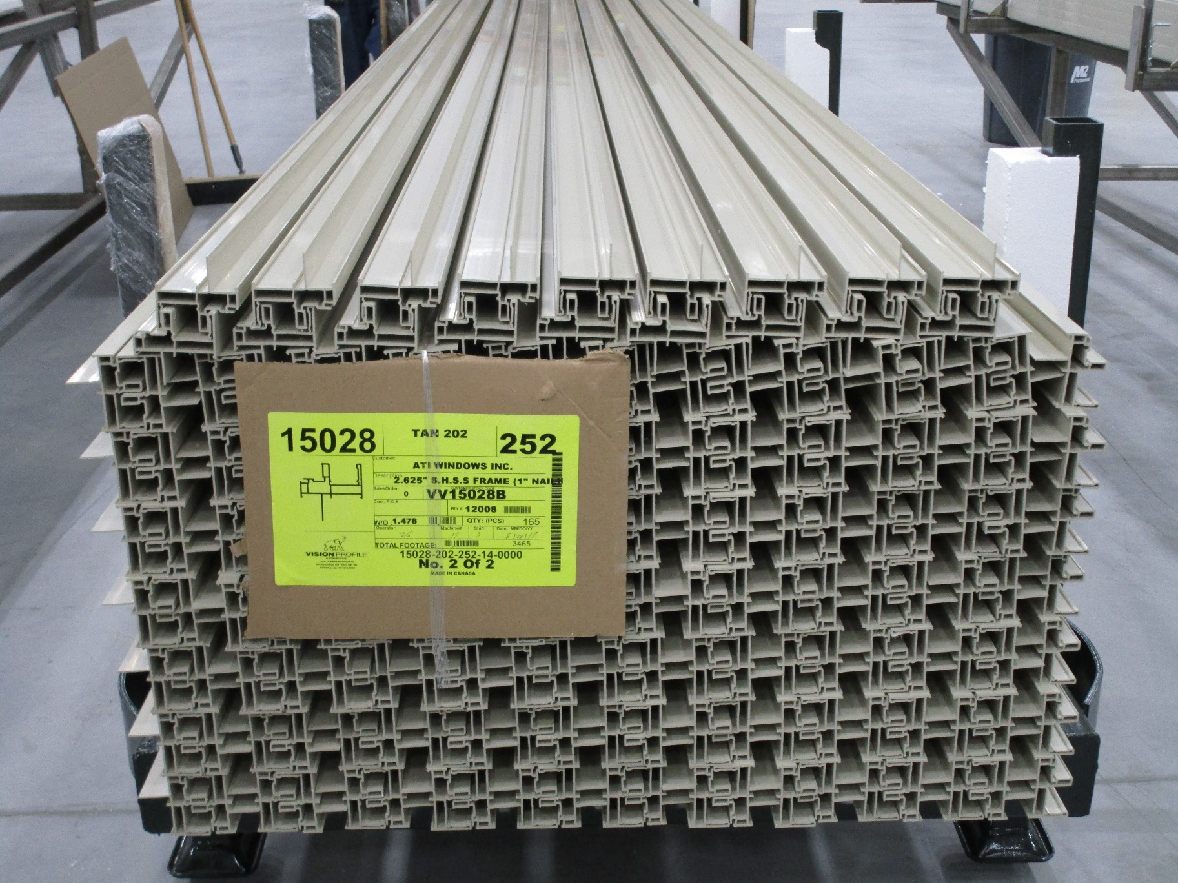
Thick Foam on 1 side

